My favourite sport

My favourite sport is football and I´m a very good player.
We practise three evenings a week and have matches on weekends.
My team and I are very good, but we sometimes have bad days, too.
We are sixteen players and have a good goalkeeper.
His name is Florian Eichbauer.
Our trainers are Roland Klabacher and Martin Steinberger.
When we can´t go to the training, then we must log off.
Our first play this year was on April 14th.
We won 6:1 against Nussdorf.
The next play is on April the 22nd.
We’ll play against Abtenau in St.Koloman and this is our list:

Eichbauer Florian

Posch Patrick Wallinger Florian Sartori Mike Neureiter Johann

Walkner Tom Göllner Matthew

Ramsauer Tom Schorn Fabian Putzer Mike

Schönleitner Mike

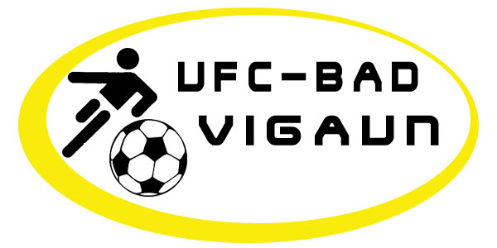
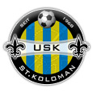
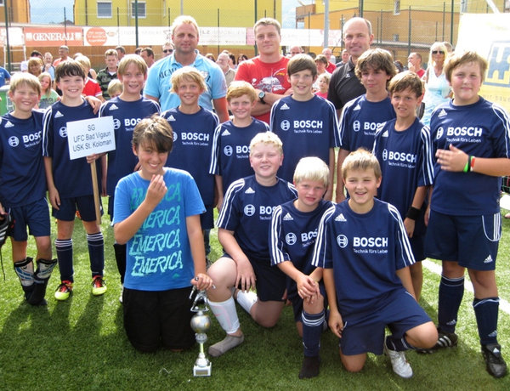
SG BAD VIGAUN/ST.KOLOMAN

