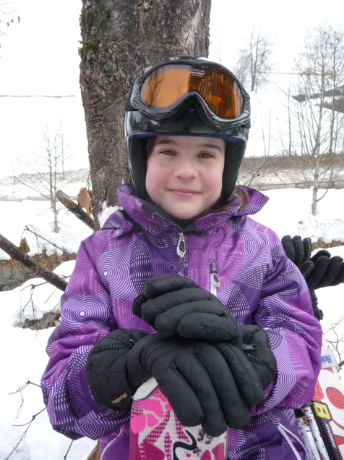
Gehmacher Christina

My favorite sport is skiing. I often go skiing in the winter.
I go with my family and with my friends.
Skiing is my favorite sport because I love the mountains and the snow.
I also like football so much, but I don’t play in a team.
I sometimes play football with my brother and his friends.
I don’t like baseball, because I´m too short.

