My favourite sports!
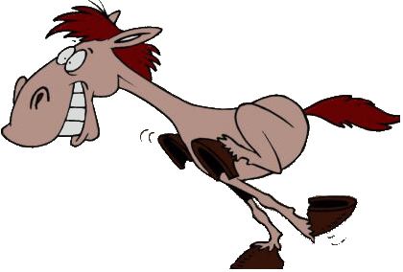
I like many sports and games: badminton, swimming, cycling, football and skiing. What I really like is riding and therefore I have a horse at home.
I often play a card game with my grandfather, This is a lot of fun.
At home we sometimes ride our bikes, but I don’t like volleyball and tennis. I think these sports are very boring.

