My favourite sport

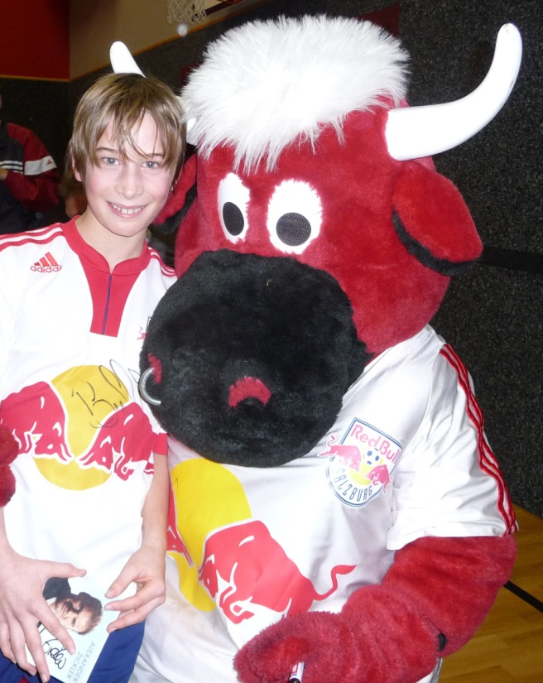
Hello, my name is Michael. I am twelve years old. I like many sports and games. What I like best is football ,it’s a very funny sport. I play in a football team and we practise three evenings a week. We have matches on weekends and we win a lot of matches. I also play badminton, but I don’t have a lot of time for other sports. I would like to go skiing more often and I would also love table tennis. At home we sometimes play Activity and I like it very much. There’s one sport I don’t like, it is gymnastics because I think gymnastics is boring.

