My favourite sport
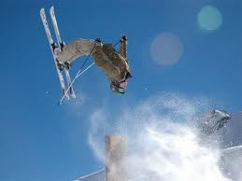
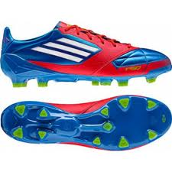
My favourite sport is football. I play in a team. I think I’m a good player. I've been playing for 7 years. My team is called USK St.Koloman. We train three times a week.
I also like another sport. It’s free skiing but I can do this only in winter. I’m good at skiing I can do a backflip and some other tricks.
I don’t like volleyball and gymnastics.
Patrick

